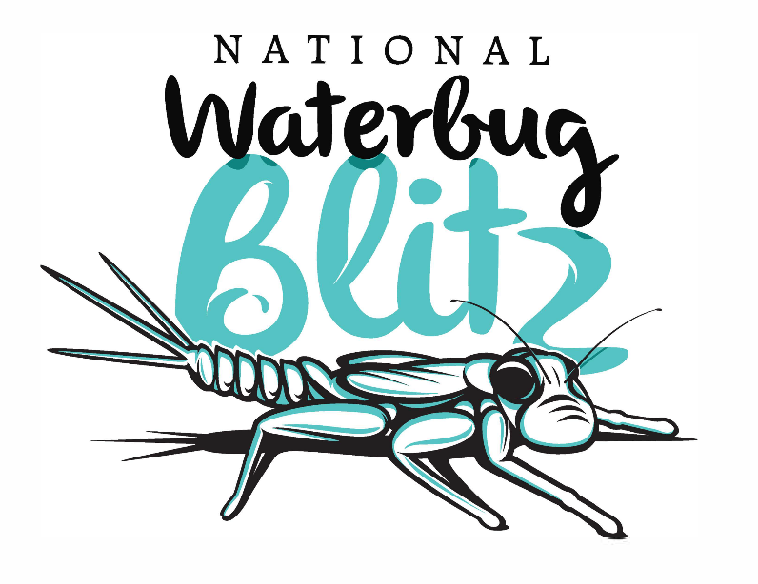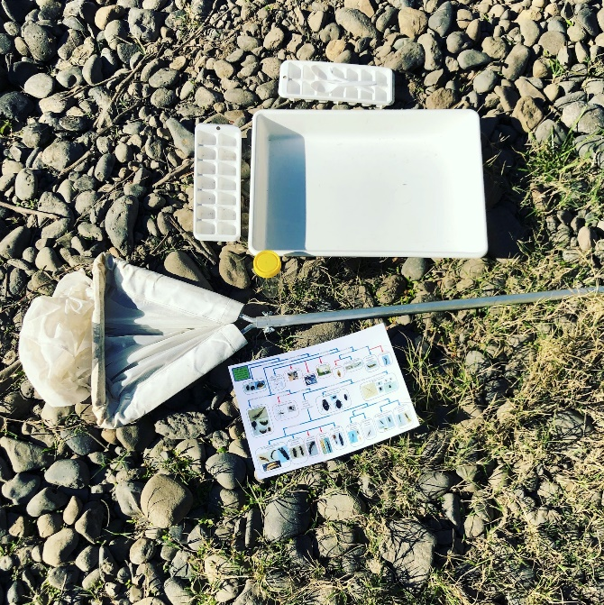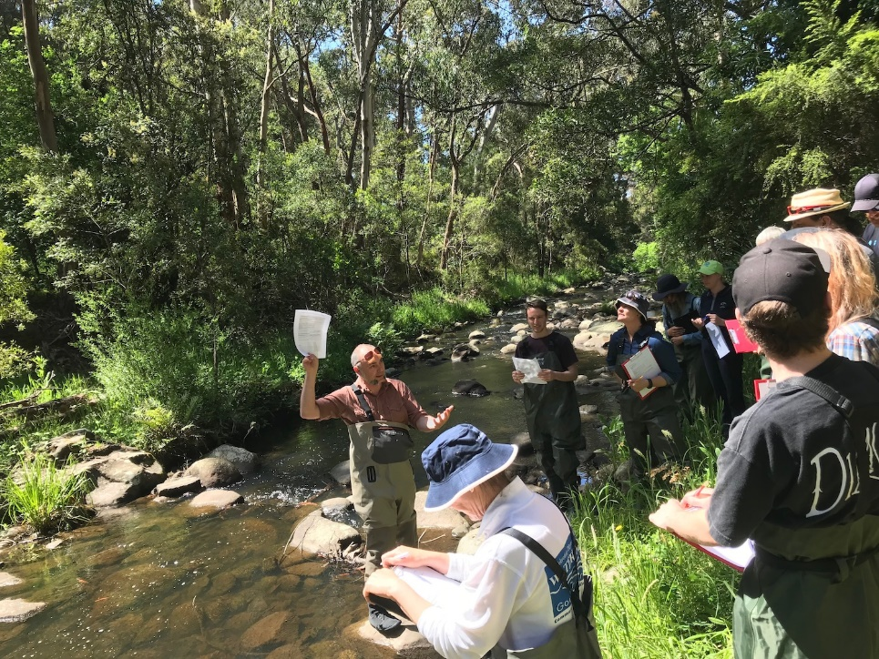

Select which session you want to advertise, or you can do both on the one flyer [delete]

For starting out, your **Introductory session** will be held on [##Date##] at [##Location##] from 10:00am – 3:00pm

For those with some experience, your **Advanced session** will be held on [##Date##] at [##Location##] from 9:30am – 4:00pm

Contact: [##Organiser Name##] on phone [##phone##] or [##email##] by [##RSVP date]

*Limited places available, so get in quick!*

The National Waterbug Blitz invites citizen scientists to work with scientists and look at water quality & river health on a local and national scale!

A Training Session is being offered in your local area for volunteers and professionals alike to learn how to collect & identify waterbugs and use the Waterbug App. Then you’ll have all the skills you need to do your own Waterbug Blitz at your local creek or river.

**On the day, please bring:**

- A folding chair

- Food & water/drinks for the day for yourself

- Hat, sunscreen, insect repellent – you will be working outdoors!!!

- Gumboots or waders

- Your smart phone with **The Waterbug App** downloaded & signed in – free on Google Play or iTunes App Store

For more information on the National Waterbug Blitz, go to [www.waterbugblitz.org.au](http://www.waterbugblitz.org.au)

**Australia’s waterways under the magnifying glass!**

**Spring into a Waterbug Blitz in your local area!**